# Lesson 1: Mastering Accuracy and Precision

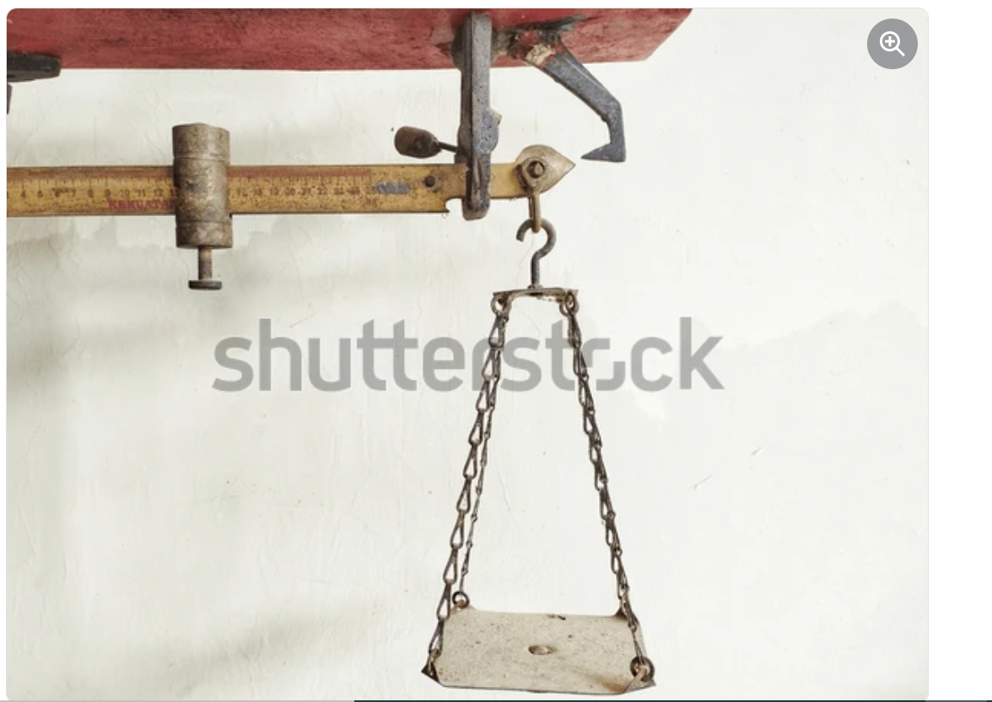

Figure 1.1: Sharpen Your Forensic Skills

## <H1> Essential Question

How can you distinguish between accuracy and precision in scientific measurements?

## <H1> Big Idea

Measuring metal quantities and reporting them with precision and accuracy has real-world implications.

## <H1> Lesson Objectives

By the end of the lesson, you will be able to:

* evaluate the accuracy and precision of data from a scientific investigation

## <H1> Curiosity Corner

As the forensic chemist examines the bracelet to determine if it is the stolen item, precise and accurate measurements of the metal’s density are crucial. Small differences in the density could reveal whether the bracelet is made of pure gold or a cheaper, gilding metal. To make this determination, the chemist must decide how close the measured density needs to be to the true value of 19.32 g/cm3.

## <H1> Key Vocabulary

* **accuracy:** the closeness of a measurement to the true or accepted value of what is being measured
* **precision:** the consistency of repeated measurements; how close the measurements are to each other, regardless of their accuracy
* **uncertainty:** the range within which the true value of a measurement likely falls, acknowledging that no measurement can be perfectly accurate
* **significant figures:** the digits in a measurement that contribute to its precision, including all nonzero digits, zeros between nonzero digits, and trailing zeros in a decimal number
* **reliability**: reliable data refers to consistent and dependable data, that is reproducible under the same conditions. Reliable data ensure that the results are trustworthy and accurately reflect the phenomena being studied

**<H1>** Ignite**:** Accuracy and Precision in Measurements  
The insurance company needed to be sure the bracelet wasn’t made of pure gold before paying the customer. To figure this out, the chemist had to carefully check all the tools to make sure they were working properly. This step was key for getting **accurate** measurements, which means the numbers should reflect the real value of the bracelet that the police found. Even a small mistake could lead to the wrong conclusion.

To ensure precision, the chemist measured the bracelet multiple times. **Precision** means that if you measure the same thing several times, the results should be very close. If the results vary too much, it’s a sign that the data isn’t reliable.

Here are some steps the chemist could take to improve both accuracy and precision:

* Double-check that all the tools are working properly.
* Look for any possible mistakes, like human errors or issues with the process.
* Take multiple measurements since having more data points can make the results more reliable.
* Control for factors such as temperature, which might affect the measurements. For example, higher temperature reduces density.
* Use math to see how much the measurements differ and how reliable the data is.
* Use different methods or tools to verify the results.
* Ask others to repeat the experiment under the same conditions to see if they get similar results.

If the density calculations are not both accurate and precise, the insurance company or owner could end up with the wrong result for their claims!

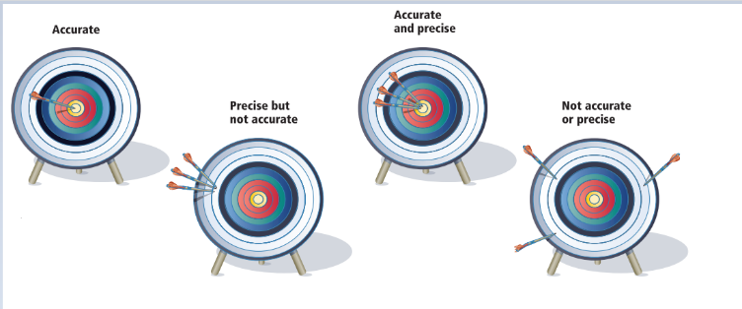

Figure 1.2. Understanding Accuracy and Precision

## <H1> Direct Instruction: Density and Sources of error

Density is a very important property of materials. Not only does it determine the use of a material, but density also serves as an identifier. For example, if the density of a piece of metal is found to be 19.32 g/cm3, you can be certain that the metal is gold. Density is a derived unit used to determine how much mass exists in a certain volume. Recall that the formula for density is the relationship between mass and volume

To learn about accuracy and precision when measuring density (or when measuring any other variable), in this lab you will be measuring the density of an unknown solid. Accuracy and precision are related to experimental procedures as sources of error. Sources of error bring uncertainty to a measurement. A common source of measurement uncertainty is human error, mistakes in procedures or observations experimenters make. Another common source of uncertainty comes from the reading instrument. Manufacturers often report the uncertainty of their instruments.

<H1>Pathfinder: Lab Experiment: Measuring Density

**Objectives:** 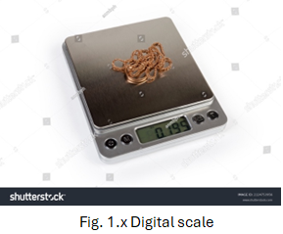

1. To determine the density of a solid.
2. Estimate measurement errors.

**Lab Safety Procedures:**

Download the lab safety procedures from the course digital components

## Materials Required

* graduated cylinder
* scale or digital balance
* water
* ruler
* graph paper or graphing software
* unknown solid provided by the teacher
* beakers
* lab notebook

### Procedure

1. Working with peers, think of a possible procedure to measure the density of a solid object using the materials included in the Materials List. You will need to measure mass and volume.
2. Write down your procedure.
3. Review your procedure considering the following questions:
   1. How many measurements of each variable would you take? (Suggestion: at least 5)
   2. Will all measurements be taken by the same students? (Suggestion, have different students do different readings)
   3. What calculations would you compute?
4. Prepare an appropriate data collection instrument and data recording device, such as a table, that properly reflects your measurements with their uncertainties.
5. After your teacher approves your procedure, you will conduct the investigation taking notes and photos as you go. Hence, prepare a lab report template that will fully reflect your procedure, your notes and photos, data, analysis, and conclusion.
6. Have your lab report template (including materials and procedures) approved by the teacher and conduct your investigation.
7. Calculate the density of your metal and report it with the correct units including its uncertainty and significant figures.
8. Compare your findings with known metals and other solid densities.
   1. For example, access <https://caetool.com/2017/10/12/p0016/> or other web pages.
   2. Can you identify your metal?
9. Fill out the lab report with your findings. You will turn in your lab report at the end of this chapter. Include your answers to the following questions in it:
   1. While conducting your investigations, did you experience any experimental errors? If so, how did it affect your findings?
   2. What patterns do you see in your repeated measurements? Are they consistent, or do they vary significantly?
   3. If you could not identify your solid, explain why not.
   4. In reference data values, densities are reported along with temperature. Why could that be?
   5. How would you measure the density of a liquid? And the density of a gas?

### <H2>Progress Check 2

1. Why must the measurements be repeated multiple times?
2. If the density values you calculated are inconsistent, how would you troubleshoot or refine the procedure to improve your results?
3. Which measurement implies greater precision 8.60 g or 9 g?
4. With how many significant figures should your findings from the lab be reported?

## <H1> Lightbulb: How Is Accuracy Expressed?

In our bracelet scenario, one of the decisions the forensic chemist needed to make is how close is close enough. That is, if the density of pure gold is 19.32 g/cm³, would 19.3 g/cm³ be close enough, or would it have to be 19.320 g/cm³? Did you notice the difference in those numbers? That presence or absence of the “20” has to do with significant figures!

### <H3> Calibration

How did the forensic chemist calibrate the instruments? Calibration is the process of adjusting and verifying the accuracy of measuring instruments by comparing the measurements of the instrument to a known standard.

Figure 1.5. Calibration

Calibration is crucial for ensuring that measurements taken with an instrument are reliable. Instruments can drift over time due to wear and tear, environmental factors, or changes in temperature and pressure. Regular calibration helps maintain the instrument's accuracy and prevents systematic errors in data collection.

## Progress Check 2

1. Are the numbers 1.25 and 1.250 the same? Explain.
2. You performed an experiment to measure the density of a substance and obtained values of 2.8 g/cm³, 2.9 g/cm³, and 3.0 g/cm³. The known density of the substance is 2.85 g/cm³. Discuss the accuracy and precision of your results and possible sources of error.

## <H1>Power Up

**The Questioneer icon**

Reflect on the following prompts to think critically about the content and come up with meaningful questions for inquiry about accuracy and precision.

1. Measurements can vary based on the instruments used.

Significant figures are essential in reporting data.

1. Calibration of instruments ensures accuracy.
2. Systematic errors can be identified and corrected through careful experimental design.

## **<H1> Lesson Check**

1. Often, the true value of the property being measured is not known. In such an experiment, scientists obtained the following results: 4.5 g, 4.7 g, 4.6 g, and 4.8 g. Evaluate whether these measurements demonstrate accuracy, precision, both, or neither. Explain your reasoning.
2. A chemist measures the volume of a bracelet and finds it is 5 cm³. Can the chemist report 5.0 cm³?
3. Why is it important to repeat the measurements and report findings with the correct number of significant figures? How do these practices contribute to the reliability of your results?
4. What happens if a measurement is not precise in scientific experiments, and how can imprecise measurements affect the results?
5. A laboratory student is tasked with determining the density of an unknown liquid. The true density of the liquid is 1.25 g/cm³. The student A performs three trials, obtaining measurements of 1.18 g/cm³, 1.20 g/cm³, and 1.19 g/cm³. In contrast, if another student B obtains 1.25 g/cm³, 1.26 g/cm³, and 1.24 g/cm³.

i. What can be said about the student’s measurements of 1.18 g/cm³, 1.20 g/cm³, and 1.19 g/cm³?

A. The measurements are accurate but not precise.

B. The measurements are precise but not accurate.

C. The measurements are both accurate and precise.

D. The measurements are neither accurate nor precise.

ii. If the student obtains measurements of 1.25 g/cm³, 1.26 g/cm³, and 1.24 g/cm³, how would you describe the data?

A. The measurements are accurate but not precise.

B. The measurements are precise but not accurate.

C. The measurements are both accurate and precise.

D. The measurements are neither accurate nor precise.

iii. Which scenario best represents a set of measurements that are accurate but not precise?

A. 1.25 g/cm³, 1.26 g/cm³, and 1.24 g/cm³ when the true density is 1.25 g/cm³.

B. 1.18 g/cm³, 1.25 g/cm³, and 1.32 g/cm³ when the true density is 1.25 g/cm³.

C. 1.18 g/cm³, 1.19 g/cm³, and 1.20 g/cm³ when the true density is 1.25 g/cm³.

D. 1.18 g/cm³, 1.25 g/cm³, and 1.30 g/cm³ when the true density is unknown.

<H1> Beyond the Lesson

Accuracy and precision are crucial in healthcare, particularly in medication administration. Accuracy ensures that the prescribed dosage—for instance, 500 mg of a drug—matches what is actually given to the patient. An inaccurate dose, such as 450 mg or 550 mg, could lead to ineffective treatment or harmful side effects. Precision, however, ensures that repeated doses remain consistent; for example, every tablet or injection contains exactly 500 mg as intended. Together, accuracy prevents errors, and precision ensures uniformity, providing reliable and safe patient care. Similarly, these principles extend to areas such as engineering, environmental science, and everyday decisions. For example, accurate and precise measurements are essential for constructing safe buildings, monitoring pollution levels. Mastering accuracy and precision not only improves personal decision-making but also contributes to broader societal outcomes, from better healthcare to more sustainable practices. These concepts help ensure that our choices—whether small or significant—are based on reliable data.